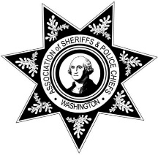

WASPC COMMITTEE MEETING TEMPLATE

**Date:** 10-08-24

**Committee Name:** Boating Safety

**Chair:** Sheriff Tom Croskrey

**Agenda**

**Purpose of Committee/Mission/Function**

The Boating Safety Committee is responsible for analyzing, researching and making recommendations to WASPC regarding matters related to boating safety. **Authority:**

**Duties:**

* The Committee shall review USCG, NASBLA guidelines, best boating practices, funding, and legislation that affects boating safety.
* The Committee shall communicate with Washington State Parks, United States Coast Guard, Washington Boating Safety Council and other stakeholders on boating safety issues.
* The Committee shall make recommendations to the Legislative Committee and Executive Board on matters relating to boating safety.

**Introductions**

**Chairperson:** Sheriff Tom Croskrey

**Co-chair:** TBD

**Old Business**

2023 review

**New Business**

Presentation of reported incidents and issues related to boating safety. This will include CDC data showing a severe under-reporting to law enforcement in our state.

Discussion and recommendations of legislation related to life jackets, inexperience operators, and alcohol related incidents.

Discussion and recommendations for funding to include available funding through the Departments of Ecology and Natural Resources.